Joe Bolewicz, PT, M.Ed
Stanwood Camano Physical Therapy and Coach Joe’s Fitness Academy
www.stancampt.com www.CoachJoesFitnessAcademy.com

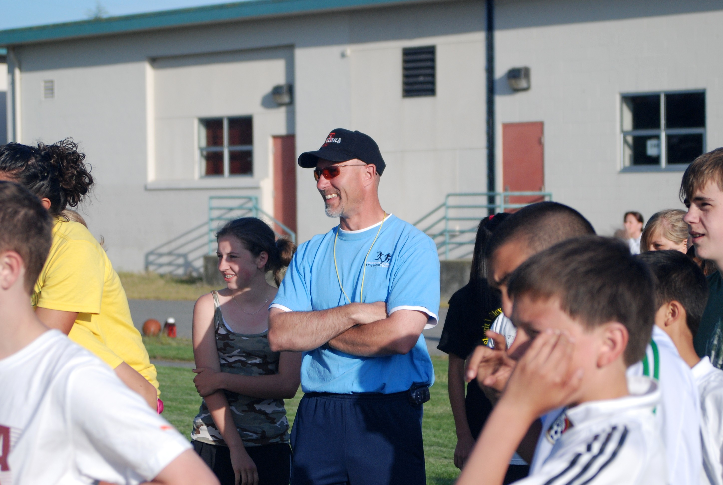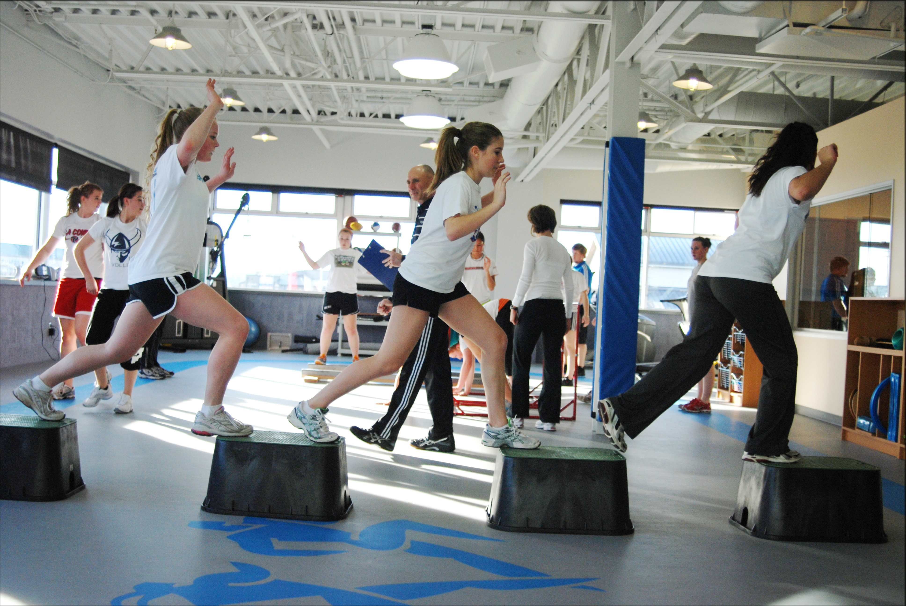

Joe Bolewicz PT, M.Ed Fun times at Coach Joe’s Fitness Academy

Objective:
Coach Joe specializes in Youth Athlete Development. Joe is a coach, mentor, lecturer, consultant, athlete, and physical therapist.

Joe’s objective is to inform and educate coaches and parents on how to appropriately address the current health and fitness needs of today’s youth while developing athleticism and enhancing competitive spirit. Joe contends that today’s youth are often missing important stages of motor skill development that can negatively impact future physical health, emotional well-being and social growth, as well as athletic improvement. Joe provides coaches and parents with the essential knowledge on the stages of motor skill development, identifying the youth’s current skill/fitness level and what strategies to implement to enhance motor skills.

Philosophy:
Coach Joe’s Fitness Academy is not like your typical speed & agility camps that are so popular today. Joe’s clinics and camps were developed through much sports science study, research and experience, with the main belief that a child must first develop basic motor skills before he/she can be expected to master sport specific skills. His emphasis is to appropriately blend sequential motor skill development with sport specific drills to effectively promote fundamental body coordination, movement, flexibility, and strength. All of which are needed for a solid foundation to successfully progress sports specific speed, agility, power, and endurance. For example, a child will be more successful in performing a lay up in basketball if he/she first has mastered skipping. With Joe’s clinics, athleticism is about body control.

By teaming with Coach Joe, both the athlete and the coach gain the competitive edge. Upon consulting with Joe high school coaches are always left amazed to discover the depth high school athletes struggle with fundamental movements. Coaches learn to identify the athletes’ “energy leaks” that impede athletic performance and how to design innovative, athletic development programs to maximize strength, power and speed. In turn, athletes develop healthy bodies and become fast, strong competitors while understanding proper lifting, drill techniques and body mechanics.

Experience:
Joe owns and operates Stanwood Camano Physical Therapy in Stanwood, Washington. Joe is also the founder of Coach Joe’s Fitness Academy. He specializes in child development and sport as well as functional rehabilitation and training. Joe works with athletes and coaches in a variety of sports including but not limited to, football, soccer, baseball/softball, the highland/Scottish games, basketball, tennis, wrestling, gymnastics, dance, golf, volleyball, swimming, cycling, track & field, marathons, skiing, and wheelchair sports.

Joe runs on-going sports and fitness camps for the local children in Stanwood where the proceeds of the camp go back to the community. At these camps he teaches kids to have fun with physical activity. He also shows coaches how to make the drills more functional for the age group, sport and fitness goal.

Joe has given numerous lectures and seminars/clinics for parents, coaches, teachers, sports teams, and healthcare providers. Joe is a guest lecturer at University of Washington School of Medicine on the topic of “Wheelchair Propulsion and Biomechanics”. Joe taught and lectured undergraduate students in biomechanics and kinesiology courses at Western Washington University. He also taught inspiring coaches and physical education teachers the fundamentals of track & field events. Joe is a developer and teacher of weight training programs at various high schools and helped North Seattle Community College develop its program.

Education:
Bachelor of Science in Physical Therapy, University of Washington
Masters of Education in Exercise Science, Western Washington University
Bachelor of Arts in Psychology, University of Puget Sound
He participated in intercollegiate football.

Presentations:
Creating Athletes for Repeat Championships: How is it that some coaches seem to always be in contention for titles? There are undoubtedly many variables to consider when answering this question. One essential secret common among successful coaches is their ability to consistently develop athletes. A successful coach knows that the development of the athlete is key to producing consistently competitive teams year after year irrespective of resources, sport knowledge and administration support. Coaches today are faced with the challenge of what to do with an athletic population that is less fit, less skilled and more prone to injury than ever before. With Creating Athletes for Repeat Championships Joe teaches coaches how to establish well balanced in-season and off-season activities for young athletes to promote fitness, emotional well-being, and athleticism. His model considers athletic age, physical development and functional/sport specific movements to build agility, quickness, strength, flexibility, and power. Joe shows coaches how to identify opportunities to create athletes for repeat championships.
Joe Bolewicz, PT, M.Ed
Stanwood Camano Physical Therapy and Coach Joe’s Fitness Academy

Contact:
Stanwood Camano Physical Therapy
9612 270th St NW
Stanwood, WA 98292

Phone: 360 629 8043
Email: joe@stancampt.com

Website: www.stancampt.com www.CoachJoesFitnessAcademy.com

